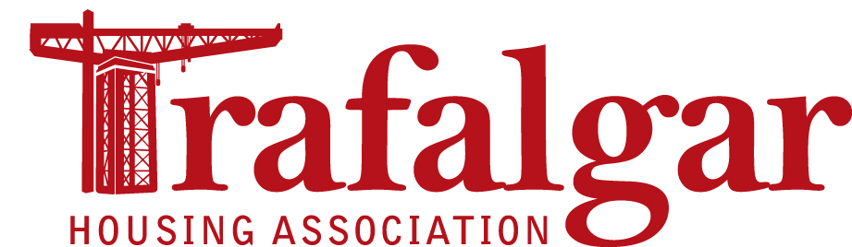

Recruitment pack

July 2019

About housing associations
Housing associations provide housing, mainly for rent but also low cost housing for sale, shared equity and mid-market rent, for people across Scotland. Social rented tenants have Scottish Secure Tenancies (SST) and the housing stock is expected to meet the Scottish Housing Quality Standard (SHQS) and the Energy Efficiency Standard for Social Housing (EESSH). Housing associations are part of the social rented sector (along with councils) and provide homes for people who are in housing need. There are a wide range of housing associations – some very large, some small, some are based in specific geographical areas (e.g. part of a city or town or a rural area) whilst others specialise in providing housing for particular groups of people (such as older people or people with particular needs). Housing associations do not trade for profit and all of the income that they generate is used to meet their running costs and invest in their current and future activities.

About Trafalgar Housing Association
Trafalgar Housing Association is a small community-controlled housing association formed in 1990 with stock in Dalmuir and Radnor Park in Clydebank. With just over 300 properties we are West Dunbartonshire’s smallest housing association but we’re a highly performing housing association with high levels of tenant satisfaction. The Association is committed to providing the highest possible level of service to tenants whilst ensuring that our rent levels remain as affordable as possible.

Our strategic direction
We recognise that for the next five years we need to ensure we continue to improve our governance, maintain service delivery and organisational performance. From our analysis of our operating environment, we know that there are some significant challenges ahead.
We will continue to embed the improvements we have made, strengthen our collaboration and partnership working, seek to re-energise our tenant and community engagement activities and deliver tangible and positive social benefits.

Strategic objectives
- People: To support our tenants, residents, staff, volunteers and future service users and ensure we provide them with a vibrant community where they can realise their full potential.
- Performance:- To maintain sector-leading performance throughout all KPIs and inspire full confidence from customers, and commitment from staff and volunteers.
- Property:- To ensure that our principle assets, the homes which we manage and maintain, compare favourably with other housing options in terms of affordability and standards.

Committee member role profile
Associations are overseen by governing bodies, which draw its members from the Associations’ membership. Trafalgar’s governing body is referred to as the Committee. Committee members are not paid for their contribution, although out of pocket expenses are reimbursed.

Purpose of the role
The Committee provides effective governance of the Association and is collectively responsible for setting and monitoring the strategic direction of the organisation and ensuring its long-term success. The Committee ensures compliance with all legal and regulatory requirements and the financial and general well-being of the Association.
Committee members determine and uphold the Association’s vision, mission, values and strategies.

Expectations of Committee members
Ensure that decisions taken by the Committee are in the best interests of the Association, its tenants and other customers, and promote the highest quality standards and effective service delivery.
Work in accordance with the Association’s Code of Conduct, ensuring confidentiality and respecting all views.
Prepare for and attend Committee meetings, making an active contribution to discussions and decision-making.
Participate in reviews of Committee effectiveness, both individual and collective, participate in opportunities for learning and development and keep up to date with sector matters.
Take collective responsibility for decisions made by the Committee.
Represent the Association positively and effectively.

Committee member roles
The key roles associated with being a Committee member of Trafalgar Housing Association are:
- To lead the Association
- To set and oversee the long-term strategic direction for the Association
- To ensure that the Committee fulfils its duties and responsibilities for the proper governance of the association
- To determine and regularly review the association’s values, strategic aims and performance standards
- To promote and uphold the Association’s values
- To ensure the Association is adequately resourced to achieve its objectives, meet its obligations and to ensure financial viability
- To take account of tenants’ and other customers’ views in respect of rents, charges and services
- To approve key policies to allow the Association to achieve its objectives
- To monitor and manage performance
- To manage any risk to the Association
- To ensure that the Association operates within, and is compliant with, the relevant legal, financial and regulatory frameworks.

