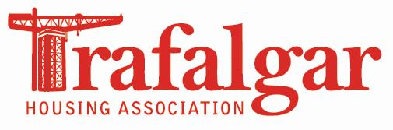
Trafalgar Housing Association
General Pension Scheme Information

Trafalgar Housing Association participates in the Scottish Housing Association Pension Scheme (SHAPS).

The SHAPS scheme includes defined benefit and defined contribution options.

