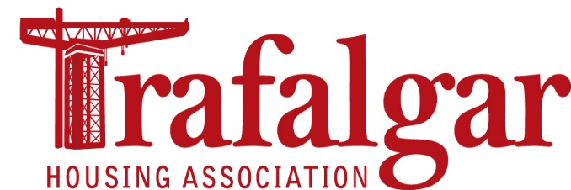

**Notification of Intention to Attend Annual General Meeting (AGM)**  
Please use this form to let us know that you can attend our Annual General Meeting (AGM) on **Tuesday 21st September 2021 at 7pm**. The AGM is being held virtually and you must tell us if you plan to attend so that we can provide you with the details that you will need to join the online meeting i.e. meeting invitation and password to access.

|  |  |
| --- | --- |
| **Your Name** |  |
| **Your Address** |  |
| **Your Email Address** |  |
| **Your Phone Number** |  |

* **I intend to be present** **at the AGM** being held virtually on Tuesday   
  21st September 2021 at 7pm.
* I am aware that I will have to log in to the meeting using Zoom, and   
  that I will need to provide you with an email in order to do so.
* **I will not be able to attend the AGM**, please record my apologies.

|  |  |
| --- | --- |
| **Your Signature** |  |

**If you would prefer to appoint someone to attend the AGM in your place, please appoint a proxy using the separate form included in this pack.**

**Data Protection**We require your name and address to confirm your eligibility to attend the meeting. It will not be used for other purposes. We require your email address in the order to send you the relevant Zoom invitation link and access password.

Please return this form no later than Tuesday 14th September 2021 to our office by post or emailto admin@trafalgarha.co.uk to confirm your attendance   
or to record your apologies.

Thereafter, it will not be used for any other purposes (unless we already hold it for other purposes, i.e. newsletters or a preferred method of communication, etc.).

We will retain copies of these notification forms for a period of 12 months to record meeting attendance and verification of signature/email address in the event of a future issue or question regarding the meeting.

We are obliged to maintain minutes of our AGM. We will use the recording facilities within Zoom to ensure the accuracy of the minutes.

As zoom also incorporates a chat facility, we will retain the log of any chat recorded within the meeting. The audio recording and chat logs will be retained for 12 months, or until converted into formal documented and agreed minutes.

We reserve the right to either ‘mute’ the microphone of, or close the connection to, any disruptive meeting attendees.

For further details as to how Zoom may be process your personal data, please visit: <https://zoom.us.privacy>

Please return this form by Tuesday 14th September 2021 so that we can get your invitation out to you in good time. Either return the form to our office or via email to admin@trafalgarha.co.uk

When completed this form should be returned no later than Tuesday 14th September 2021 by **email** to [**admin@trafalgarha.co.uk**](mailto:admin@trafalgarha.co.uk)or to our office at:

**Trafalgar Housing Association  
430A Dumbarton Rd, Dalmuir, Clydebank   
G81 4DX**



**31st Annual General Meeting  
Tuesday 21st September 2021**

|  |
| --- |
| **Proxy** |

You must use the wording shown below to appoint a representative to vote at the virtual Annual General Meeting for you.

**I** (please insert your name here) ……………………………………………………………….   
am a Member of Trafalgar Housing Association.

**My address is:**

**I hereby appoint:**

**Who lives at:**

to be my representative and vote for me at the Association’s Annual General Meeting on Tuesday 21st September 2021 and any other dates that the meeting continues on.

**Your Name:**

**Your Signature:**

**Date:**

When completed this form should be returned no later than Tuesday 14th September 2021 by **email** to [**admin@trafalgarha.co.uk**](mailto:admin@trafalgarha.co.uk) or by **post** to:   
  
**Trafalgar Housing Association  
430A Dumbarton Rd, Dalmuir, Clydebank   
G81 4DX**

**FOR OFFICE USE ONLY**

Membership Check: Checked by: Date:



If you are a Shareholder of the Association you are entitled to stand for election to the Management Committee. If there are more candidates than places available an election will take place at the AGM but before this you must complete the attached nomination form. Please remember that these forms have to be completed by the Shareholder standing for election to the Committee and they have to be agreed by a Shareholder making a nomination and returned to our office by **Tuesday 14th September 2021 at 4.00pm**. If you require assistance in identifying other Shareholders to nominate you please contact the office for advice.



**TRAFALGAR HOUSING ASSOCIATION**

# NOMINATION FOR ELECTION ON TO

# THE COMMITTEE OF MANAGEMENT

## To be completed by member making nomination

I ………………………………………………………. hereby nominate

(Name of member)

…………………………………………………………. for election on to

the Committee of Management of Trafalgar Housing Association.

Nominating Member's Signature: ……………………………………….

Membership Certificate Number: ………………………………………..

Date: ………………………………………..

1. **To be completed by member accepting nomination**

I …………………………………………………………… hereby agree to be

(name of nominee)

nominated for election on to the Committee of Management of Trafalgar Housing

Association.

Signature: …………………………………………………

Name: ………………………………………………………

Address: ……………………………………………………

Membership Certificate No. ………………………………

Occupation: …………………………………………………

Date: …………………………………………………………

**Notes: All nominations to be completed and returned to the Association's offices at 430(a) Dumbarton Road, Clydebank or by email to** [**admin@trafalgarha.co.uk**](mailto:admin@trafalgarha.co.uk) **by Tuesday, 14th September 2021 at 4.00pm.**